1. Write a program to simulate a standalone traffic signal system.

A traffic signal considered must have two components as detailed below.

**First Component:**

First component will

1. Displays the current signal light, i.e., Green/Red/Amber color.
2. Displays a countdown time remaining in seconds before changing the signal light.

This is done by using a state machine as explained below to alternate between signal lights in order to co-ordinate the road traffic.

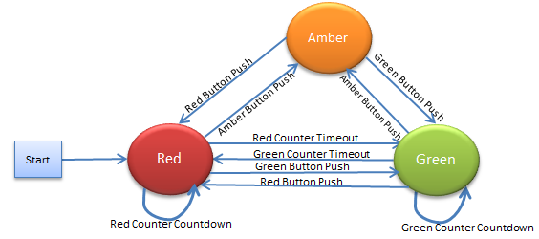

At the start of the program, the signal light will be Red. During normal un-interrupted traffic conditions, there will be only two signals Red and Green. Amber color will be changed only by an explicit event like traffic men pressing the Amber button.

There will be two counters for Red and Green states. The counter will start counting to zero from a predefined count value as set by the traffic police men. When the state machine is in Red/Green state, the corresponding counters start decrementing, and finally when it is zero the state machine will change to its next state and start countdown with another counter.

**First Component Requirements:**

* 1. The program displays the current state of the signal light,
  2. The countdown value every second.

Example output:

Current Signal Light: Red

Count down time: 60

Display at Nth sec.

Current Signal Light: Red

Count down time: 59

Display at (N+1)th sec.

Current Signal Light: Red

Count down time: 0

Display at (N+60)th sec

Current Signal Light: Green

Count down time: 40

Display at (N+61)th sec… etc

Current Signal Light: Amber

Count down time: 20

Changed to Amber display when Second component sent message “AMBER Signal”.

**Second Component Requirements:**

The second component must simulate a push button features to allow a traffic policemen to change traffic signal light to any color (Green/Red/Amber) based on his/her priority.

Before changing to a desired state, delay time of 10 sec needs to be introduced.

The first and second components must be implemented separately as a Linux processes.

CLI menu of Second Component

RED Signal Sent

1. Send RED push button signal.
2. Send GREEN push button signal.
3. Send AMBER push button signal.
4. Exit

GREEN Signal Sent

AMBER Signal Sent

Any IPC communication mechanism can be used for message exchanges between first and second components.